Learning Technology Grant (LTG) Year End program report
Year 1: September 1, 2018 to June 30, 2019
Deadline: Submit to ltg2018@nysed.gov no later than October 4, 2019

Date filed: October 4, 2019
Grant Recipient Name: Edutech (Wayne Finger Lakes BOCES)
Name of person filing report: Mike Morone, mike.morone@edutech.org
- Describe with specificity the evidence that you have fully or partially met the goals that were outlined in your proposal. Please provide specific results for each goal that was intended to be met in year 1. This response should be based upon the information in the LTG project plan and program narrative that were submitted as part of your proposal.
We started the grant with 32 districts expressing an interest. Shortly after we were awarded the grant, six of those districts withdrew for various reasons. That left us with 26 participating districts.
Goals 1 and 2: We set up and modified 26 online STEM courses for student enrollments in year two. The modifications were done this summer by six of our online teachers, totaling 100 hours of work.
Goal 3.1: Provide two days of day of professional development around supporting online learners for Online Learning Coordinators. We delivered this training on both sides or our areas, for a total of 34 participants. This was done by Wayne Finger Lakes BOCES staff and the University of Rochester staff jointly. We processed all stipends for these trainings.
Goal 3.2: We provided four-hour Blended Learning workshops to a total of 105 teachers. This was done by University of Rochester staff and facilitated by Wayne Finger Lakes BOCES staff. We processed all stipends for these trainings.
Additionally, the grant purchased 150 Chromebooks and they were distributed evenly among the participating districts. These Chromebooks will be used by students in online courses in Year 2.
We set up and populated a Learning Technology Grant website for artifacts (https://www.edutech.org/resources/accelerateu-online-learning/ltg-grant).
We have not formed our Professional Learning Community, which was due by May 2019. However, we will work on this in October. With so much going on in other areas, we had to prioritize.
We have not formed our Online Learning Advisory Team, which was due by April 2019. We have discussed it with several stakeholders and will initiate it in October. As with the PLC, we had to prioritize, because of the condensed time frame in which to complete activities.

- If you have not met one or more of the year-one goals, what factors came in to play that made it difficult to do so? Please be very specific, as this will help us to improve the process and assist you and others to be successful going forward. List the goals that were not met at all or were partially met and the specific reason why this occurred. If you fully met all goals, please list them and describe the factors that came into play that made it possible for you to do so.
As stated above, we did not form our Professional Learning Community and Online Learning Advisory Team because of competing deadlines that we prioritized ahead of these activities. We did discuss goals, logistics, strategies, and stakeholders - so we are well-positioned to initiate these activities in October 2019.

- Please list the artifacts that you have produced in year 1 that will be posted on your website. For each artifact, state its related goal and provide a link to the web page where the artifact is posted. If it has not yet been posted, state when and where it will be posted.
Our portal is located at https://www.edutech.org/resources/accelerateu-online-learning/ltg-grant.
A screenshot of the site is below. Above that is a brief description of the contents of each section.

GRANT NARRATIVE/RFP: Official grant documents, summarized

GRANT SUMMARY: A 7-page summary of the grant, initially created in May and updated in August. Sent to all who had questions about the goals/intent of the grant, the grant activities, and the description of the online STEM courses.

PARTICIPATING DISTRICTS – a listing of the 26 participating districts

STEM/CTE COURSES – Listing of the online STEM courses with links to syllabi.

PROFESSIONAL DEVELOPMENT – a summary of all PD sessions (both OLC and BL), including dates and registration information. Also included are the full PowerPoint presentation documents.

ONLINE/BLENDED PROFESSIONAL LEARNING COMMUNITY – not populated yet

EVALUATIONS – Links to our online evaluation forms for both OLC and BL training sessions. We are currently in the process of collecting the evaluation forms.

BUDGET – not populated yet. We will upload all budget documents, including FS10, FS10A, and MWBE documents.

DOCUMENTS/RESOURCES – School Visit documentation sheet and an updated version of our summary document

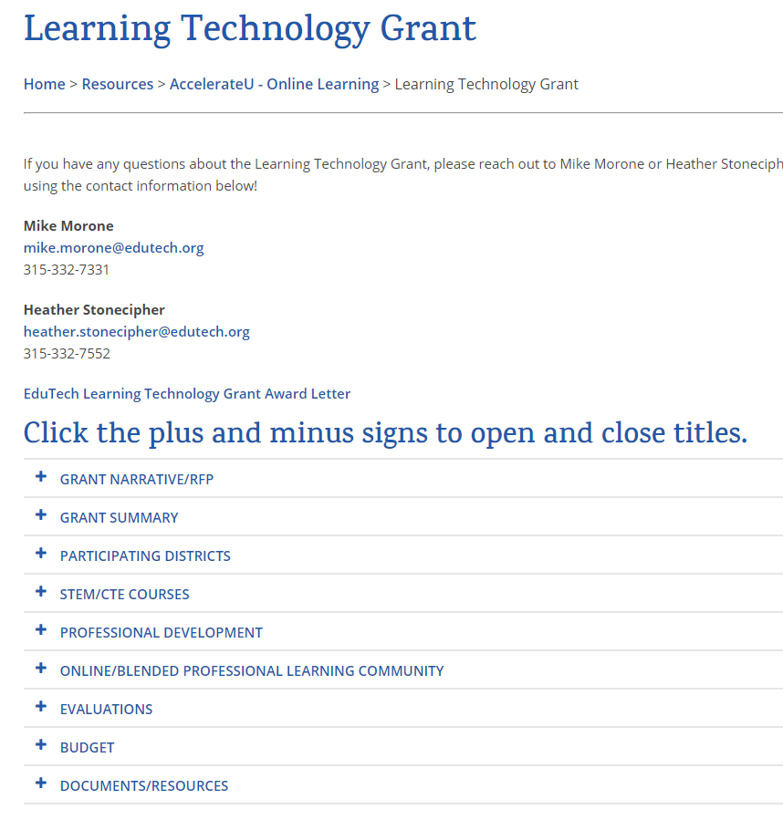

- How would you rate the assistance provided to you by the Ed Tech staff? Feel free to elaborate on your response.
Mary Ann Valikonis and staff provided timely responses and advice. She was encouraging and never intimidating. She was approachable and had patience, despite our many questions and budget changes.
☒Excellent ☐Very Good ☐Average ☐Fair ☐Poor ☐N/A

- Please use this space to provide any additional information about your grant activities in year 1.
During Year 1, we held several planning meetings both in person and by video conferencing with the UR folks. We visited each district at least once, offered to visit on other occasions, and attended one evening parent event. We submitted three FS10A forms, in attempts to use all of our grant money to benefit our districts, given the condensed time frame.

- Please use this space to provide any additional feedback.
As of today, we have two districts (both remaining private schools) who may be dropping out of further participation in the grant. This is unfortunate, and we have repeatedly encouraged them to continue to participate.
As of today, we have enrolled students in 16 online STEM courses. We had anticipated more enrollments by now, but we believe districts are busy with start-of-year activities – so we expect more enrollments later in the fall in in the spring semester. We fully plan to use all allotted enrollments and have been encouraging districts to talk to students about enrolling in these courses. Our goal is to have students enrolled in 120 online STEM courses, while continuing our PD with Online Learning Coordinators in the support of these students. We also plan on visiting these students on a monthly basis, to determine if that increased contact equates to higher success rates.
We have spent a great amount of time strategizing how best to use our grant money, without returning it unspent. To this end, obtained help in orienting/visiting students, from a former coworker. We feel that her involvement will increase student success rates.
We are also busy recruiting teachers to participate in a related University of Rochester course that was approved. The course is titled “Digitally-Rich Teaching and Learning in K12 Schools”. To date, we have two strong candidates out of a possible field of ten. These teacher-leaders have the potential to boost capacity in their districts for delivering more student-centered learning through technology integration, as described below.
This is the core course in the Warner School Advanced Certificate in Digitally-Rich Teaching in K-12 Schools, and it has been specifically designed to prepare K-12 teachers to integrate technology in their classrooms in a way that promotes more student-centered and differentiated instruction (see http://k12digital.org/courses-programs/ for more information). Teachers taking this course will receive training equivalent to a minimum of 100 hours of professional development.

We are continuing the grant activities in Year 2 and hope to progress towards our goals in the coming months.

If you require more detailed information, please let us know.

Thank you.

Mike Morone

Online STEM Courses
- 3D Modeling, (one semester), requires Windows PC
- Animation, (one semester),
- AP Computer Science, (two semesters)
- Audio Engineering, (one semester), Requires Windows PC
- Augmented and Virtual Reality, (one semester)
- Automotive Basics, (one semester
- Biotechnology, (one semester)
- Bitcoin and the Future of Money, (one semester)
- Digital Information Technology, (two semesters)
- Engineering and Technology Concepts, (one semester)
- Engineering Introduction (one semester), has hands-on activities
- E-sports and the History of Video Games
- Flying Cars and the Future of Transportation, (one semester)
- Foundations of Programming, (two semesters), Requires Windows PC
- Game Design Basic, (one semester), Requires Windows PC
- Game Design 1, Creating a Game, (one semester)
- Game Design 2, Introduction, (one semester)
- Manufacturing Introduction, (one semester)
- Middle School Coding 1, Introduction, (one semester)
- Middle School Coding 2, Creating a Game, (one semester)
- Procedural Programming, (two semesters), Requires Windows PC
- Python Multiplayer Adventure, (one semester), Requires Windows PC
- Robotics, (one semester)
- Small Engine Repair, (one semester)
- The Internet of Things, (one semester)
- Wearable and Implantable Technologies, (one semester)

Edutech’s Learning Technology Grant
Summary, September 2019

Goals
- Expand educational opportunities to high school students through online and blended learning
- Increase the availability of STEM courses in computer science and engineering
- Increase capacity of districts to provide online/blended learning

Summary
- Years 2 (July 1, 2019) and 3 will provide approximately 5 free online STEM courses per district.
- Years 2 and 3 will provide for one day of PD and coaching activities
- Years 1-3 will provide a PLC to share information on high quality online/blended learning

Online STEM Courses (subject to change)
- 3D Modeling, (one semester), requires Windows PC
- Animation, (one semester),
- AP Computer Science, (two semesters)
- Audio Engineering, (one semester), Requires Windows PC
- Augmented and Virtual Reality, (one semester)
- Automotive Basics, (one semester
- Biotechnology, (one semester)
- Bitcoin and the Future of Money, (one semester)
- Digital Information Technology, (two semesters)
- Engineering and Technology Concepts, (one semester)
- Engineering Introduction (one semester), has hands-on activities
- E-sports and the History of Video Games
- Flying Cars and the Future of Transportation, (one semester)
- Foundations of Programming, (two semesters), Requires Windows PC
- Game Design Basic, (one semester), Requires Windows PC
- Game Design 1, Creating a Game, (one semester)
- Game Design 2, Introduction, (one semester)
- Manufacturing Introduction, (one semester)
- Middle School Coding 1, Introduction, (one semester)
- Middle School Coding 2, Creating a Game, (one semester)
- Procedural Programming, (two semesters), Requires Windows PC
- Python Multiplayer Adventure, (one semester), Requires Windows PC
- Robotics, (one semester)
- Small Engine Repair, (one semester)
- The Internet of Things, (one semester)
- Wearable and Implantable Technologies, (one semester)

Contacts
- Mike Morone, (315) 332-7331, mike.morone@edutech.org
- Heather Stonecipher, (315) 332-7552, heather.stonecipher@edutech.org
- Mary Jane Schenk, mjswfl@gmail.com

Participating Districts
Attica ; Avon; Batavia; Byron-Bergen; Caledonia-Mumford; Clyde-Savannah; Dansville; Gananda; Geneseo; Le Roy; Letchworth; Livonia; Lyons; Marion; Midlakes; North Rose-Wolcott; Palmyra-Macedon; Pavilion; Perry; Red Creek; Red Jacket; Romulus; Seneca Falls; Sodus; Warsaw; Wayland-Cohocton; Wayne; Notre Dame High; Hillside Children’s Center - Varick; Finger Lakes Christian School; Gilead School; Genesee Country Christian School

EduTech Grant Site: https://www.edutech.org/resources/accelerateu-online-learning/ltg-grant

Note: Year 2 of the grant is 2019-20. We like to have districts use their 5 free online courses in semester 1, if possible. Let us know if you do not intend to use your course slots, so we can offer them to other districts.

Course Descriptions

3D Art Modeling | Are you interested in a career in technology? Are you curious about working in fields like virtual reality, video game design, marketing, television and motion pictures, or digital imaging? If so, this course in 3D Modeling is a great place to start as it is the foundation for all these career paths. Gain a deeper understanding of graphic design and illustration as you use 3D animation software to create virtual three-dimensional design projects. Hone in on your drawing, photography, and 3D construction techniques and develop the skills needed to navigate within a 3D digital modeling workspace. This course is an excellent introduction to careers in the fast-growing field of technology and design.
Animation  (one semester)  Requires Windows PC or Macintosh | 2D animation creates movement in a two-dimensional artistic space. And in this course, you will learn the necessary skills to do just that. 2D Animation will give you the tools to conceptualize and bring your animation dreams to life! Using a variety of software and design programs, you’ll have the power to transform your creative notions into reality! Design, define, and complete a variety of digital design projects including creating your own website! Learning about 2D Animation could lead to a thriving career in the growing world of technology and animation!
AP Computer Science  (two semesters)  Requires Windows PC | The AP Computer Science A course is an introductory computer science course. A large part of the course involves developing the skills to write programs or parts of programs that correctly solve specific problems. The course also emphasizes the design issues that make programs understandable, adaptable, and when appropriate, reusable. At the same time, the development of useful computer programs and classes is used as a context for introducing other important concepts in computer science, including the development and analysis of algorithms, the development and use of fundamental data structures, and the study of standard algorithms and typical applications. In addition, an understanding of the basic hardware and software components of computer systems and the responsible use of these systems are integral parts of the course.
Audio Engineering  (one semester)  Requires Windows PC | In this introductory course, students learn about the physics of sound and the history of recording technologies. They learn about the four stages of professional music recording projects: recording, editing, mixing, and mastering. Using Audacity, an open-source recording and mixing program, they practice the techniques used by sound engineers to produce multitrack recordings. Through a series of engaging hands-on projects, they learn the fundamental concepts of audio engineering.
Augmented and Virtual Reality  (one semester) | Separating hype from reality is hard… especially in the fast-growing and evolving space of augmented and virtual reality (AR/VR). Recent advances in technology has allowed AR/VR systems to become extremely sophisticated and realistic. This course introduces students to the technologies that underpin AR/VR systems. Then the course walks through 7 applications of AR/VR and how they will change and impact numerous aspects of our lives and the economy. Students will also learn about and discuss the risks and side effects of these systems, including health, privacy, and ethical implications.
Automotive Basics  (one semester) | This course is designed to accomplish two goals. First, it is to give you basic knowledge of automobile systems and how they work together to make your car run. Second, it is to prepare you to make educated decisions about maintaining your vehicle. Believe it or not, you can maintain your vehicle in good running condition without paying huge fees to service technicians! Two of the biggest benefits of doing these things yourself are the amount of money you will save and the confidence you will have in yourself.
Biotechnology  (one semester) | In this course, you will explore the history of biotechnology, including early attempts at food preservation, the development of antibiotics, and changes to food crops around the world. You’ll also learn more about some of the challenges of biotechnology, such as the growth of antibiotic resistant bacteria and questions about the safety of commercially produced genetically modified organisms (GMOs). Finally, you’ll research new biotechnologies and how they are changing the world we live in.
Bitcoin and the Future of Money  (one semester) | In this course, students will learn all about bitcoin, including its history, development, and context within the modern global economy. Students will learn the basic cryptographic principles that underlie bitcoin and gain confidence by demonstrating strong security principles in storing and transacting bitcoin. Key principles such as mining, wallets, and hashing will be introduced. And finally, they will be familiarized with the nascent industry of digital currencies and how they function.
Digital Information Technology  (two semesters) | Dive into an exciting course that will provide you with the foundational skills needed for exciting careers like game development, military defense, web design, and software engineering! You will explore Microsoft Office online applications, web design, emerging technologies, operating systems, project management, communication methods, Information Technology careers, and much more in this course. Learn about your strengths and how they relate to different career paths.
Engineering Introduction  (one semester) | What do you think of when someone says "engineering"? Do you think of designing buildings or bridges? Do you consider researching new ideas for automobiles? How about designing equipment to search for new sources of energy? Researching and designing better products and creating new solutions for existing problems are all good examples of engineering, and, obviously, there are many more!
Engineering and Technology Concepts  (one semester) | Each day, we are surrounded by technology and engineering projects. From our phones to the bridges we drive over, engineering and technology influence many parts of our lives. In Concepts of Engineering and Technology, you will learn more about engineering and technology careers and what skills and knowledge you'll need to succeed in these fields. You'll explore innovative and cutting-edge projects that are changing the world we live in and examine the design and prototype development process. Concepts of Engineering and Technology will also help you understand the emerging issues in this exciting career field.

E-sports and the History of Video Games | In this course, students will learn about the technologies and design principles that have been the foundation the development of video game technology over the last 50 years. Students will examine and discuss the impact of video games on culture and the economy. Students will learn about the current gaming and e-sports landscape, including strategies and techniques of top teams and individuals. This course will also discuss the risks and dangers of video games and understand how to set appropriate time and content parameters. Finally, the course will identify career paths and opportunities for those who are passionate about gaming.
Flying Cars and the Future of Transportation  (one semester) | This course introduces students to the newest futuristic transportation technologies out there. Students gain familiarity with the history of transportation development and understand a framework with which to evaluate new transportation modes. Then the course dives into 10 different technologies on the horizon. Students examine the technologies, the pros and cons of each mode, and explore potential career paths in these emerging fields.
Foundations of Programming  (two semesters)  Requires Windows PC | Foundations of Programming (FoP) will teach students the fundamentals of programming using the computer language Python. The course provides students with the concepts, techniques, and processes associated with computer programming and software development. Students will also explore the many programming career opportunities available in this high-demand field.
Game Design Basic  (one semester)  Requires Windows PC | This course is for anyone who loves gaming and wants to design and build original games from scratch. Students learn how to use popular game-development software to create engaging, interactive games in a variety of styles. After learning about game genres, students learn about aspects of the game-design process. From there, it’s on to a series of increasingly challenging hands-on projects.
Game Design 1,  Introduction  (one semester) | Tap into your creative and technical skills as you learn about the many aspects involved with designing video games. You will learn about video game software and hardware, various gaming platforms, necessary technical skills, troubleshooting and internet safety techniques, and even the history of gaming. And to top it all off, you’ll even create your very own plan for a 2D video game! Turn your hobby into a potential career and go from simply being a player in a virtual world to creating one!
Game Design 2,  Creating a Game  (one semester) | By signing up for Game Design 1b: Building a Game, you will learn the skills needed to conceptualize, design, and fully create your very own video game. Explore various video game software and hardware, sharpen your coding skills, learn about game storylines, player progression, and algorithmic decision making. Learn to analyze player goals, actions, rewards, and challenges, among many other game play components. Utilize the 21st century skills of creativity, critical thinking, communication, collaboration, and technical expertise. When you sign up for Game Design 1b: Building a Game, you are putting yourself at the forefront of a future in technology!

Manufacturing Introduction  (one semester) | In this course, you’ll learn about the types of manufacturing systems and processes used to create the products we buy every day. You’ll also be introduced to career opportunities in the manufacturing industry including those for engineers, technicians, and supervisors. As a culminating project, you’ll plan your own manufacturing process for a new product or invention!
Middle School Coding 1, Introduction  (one semester) | In Middle School Coding 1a, you will learn all about the technology you use in your day-to-day life as well as explore how the internet functions. Get an introduction to the basics of computer science and discover how to create and build your very own website using HTML and CSS. You’ll also become familiar with programming languages like JavaScript and Python Programming. You will leave the course with your very own portfolio of work that will showcase your skills and all that you’ve created.
Middle School Coding 2, Creating a Game  (one semester) | Building on what you learned in Middle School Coding 1a, you’ll expand your knowledge of programming languages and web development and further explore Advanced Python, HTML, and JavaScript. You will also learn the difference between web development and web application development and continue to grow your portfolio, which will serve to highlight everything you have learned and created in the course.
Procedural Programming  (two semesters)  Requires Windows PC | Procedural Programming (ProP) teaches advanced programming concepts using the computer language Python. You will learn techniques and processes associated with computer programming and software development. This course continues the study of computer programming concepts with a focus on the creation of software applications employing procedural programming techniques. After successful completion of Foundations of Programming and Procedural Programming, students will have met Occupational Completion Point B, Computer Programmer Assistant, SOC Code 15-1131.Follow the link below for the complete Department of Education description of this course:http://www.fldoe.org/core/fileparse.php/18567/urlt/9007500-1819.rtf. Pre-Requisites: Foundations of Programming
Python Multiplayer Adventure  (one semester)  Requires Windows PC | In this course there are six modules teaching students the Python language. This course assumes no prior coding knowledge as students follow the lessons to program multiple complete programs in Python
Robotics  (one semester) | The Cubit Exploring Technology STEAM Course curriculum immerses students in learning robotics through a series of creative projects solving real-world problems. This course has been specifically designed with STEAM career paths in mind, formulated to support students in key skills needed to pursue these fields. Through these projects, students will put into practice key concepts and skills in science, technology, engineering, art, and mathematics. Students learn to design, code, construct, and refine robotic solutions to current issues in six fields of engineering and technology.
Small Engine Repair  (one semester) | This course is not a “how to” course on rebuilding engines or improving performance. It is designed for you to be able to figure out just what makes that engine run. You’ll achieve this through a series of readings and quizzes as well as an optional hands-on assignment. This is what you’ll be able to do when you are finished with this course:  - Identify the key systems and components that enable small engines to operate.  - Analyze mechanical problems to determine best method of repair.  - Summarize skills needed in various small-engine-related careers.
The Internet of Things  (one semester) | First, we had the Internet of computers. Then with the advent of email and social media, along with mobile technology, it became the Internet of people. Today’s world is increasingly becoming the Internet of things. With advances in battery power, sensors, and computer chips, more and more devices are being connected to the internet. This will allow them to be monitored, controlled, and used more effectively for people and businesses. This course will examine the trends and opportunities surrounding the Internet of Things (IoT). Students will learn about the technologies, hardware, and software that underpin the Internet of Things. The course will examine a variety of end-market applications in our homes, businesses and cities. Finally, students will learn about the many career opportunities that IoT will enable.
Wearable and Implantable Technologies  (one semester) | From hearing aids to pedometers to smart watches, humans have made and worn devices to overcome physical deficiencies, count their steps, and communicate. With the continue miniaturization of chips and sensors, combined with increasing sophistication of artificial intelligence, wearable technology has proliferated into countless end-markets. This course will introduce students to wearable technologies and the components and software that make these technologies possible. The course will also evaluate several applications of wearable technologies in various industries. Finally, the course will examine and discuss the implications of wearable technology, including its pros and cons, and potential implications to our health, privacy, and society.

