Phone: 1.800.722.5797
Email: Schooltool@edutech.org

End of Year Tasks &
Preparation for Next School Year

- Schedule Offset – complete by 6/30
- Graduating Seniors – complete by 6/30
  - Diploma
  - Graduation Date
  - Post Grad Plan
  - Career Path
  - Exit Enrollment

- Advancing Grade Level for In-district Students – complete on or after 7/1

- Enrollment Records for All Other Students– complete by 8/16
- Retained Students
- UPK Students
- PS Students
- ODP Students
- GED Students
- Foreign Exchange Students
- Instructional Only Students
- Preschool New Referral Students
- CSE Responsibility Only Students

- Preparation for Next School Year – complete by first day of school

- SCHEDULE OFFSET: Complete by 6/30
Maintenance > Counseling > Building School Level Options

Set the Schedule Offset to 30 for each bldg. Save.
Adding a schedule offset extends the start of the school year by 30 days to give you time to advance your students to the next grade level.

- GRADUATING SENIORS: Complete by 6/30
Notes: Graduate (Exit) Seniors after the school year has ended and report cards have been printed. Diploma, Graduation Date, Post-Grad Plan and Career Path can be entered at any time.

Diploma
Batch:
- Counseling > Batch Enrollment Edit
- Select a group of seniors who have earned the same Diploma, Continue
- Select Diploma from the dropdown
- Select the specific Diploma
- Save
Individual Student:
- Census > Student Tab
- Edit this years enrollment
- Select a Diploma
- Refresh

Note: Additional Diploma types can be added in Maintenance > Counseling > Diploma.

Graduation Date
Batch:
- Counseling > Batch Enrollment Edit
- Select the group of seniors who are graduating, Continue
- Select Graduation Date from the dropdown
- Select this years Graduation Date
- Save
Individual Student:
- Census > Student Tab
- Edit this years enrollment
- Select the Graduation Date (to the right of the “Class of” field)
- Refresh

Note: Graduation dates can be added in Maintenance > Counseling > Graduation Dates.

Post Graduation Plan
Batch:
- Counseling > Batch Post Grad Plan
- Click the blue arrow for Batch Add Post Grad Plan
- Select a group of seniors who have the same plan, Continue
- Select the plan
- Enter date
- Click the green plus
Individual Student:
- Counseling Search > Notes Tab > Post Grad Plan
- Click the green plus
- Select the plan, enter date
- Save

Career Pathway
Batch:
- Census > Batch Edit Demographics
- Select a group of seniors who have the same Career Pathway, Continue
- Select the Path
- Save
Individual Student:
- Census > Demographics Tab.
- Click Edit.
- Enter the Career Pathway.
- Save

Graduate (Exit) Seniors
- Go to Counseling > Auto Grade Advancement.
- Use the pre-screen options (below) to locate your 12th graders.
- Click Search.
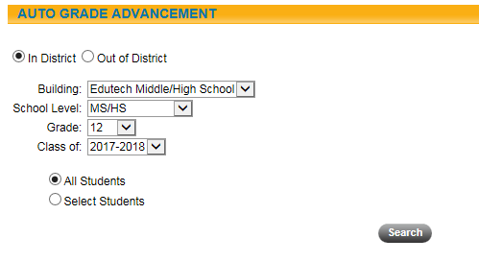

The Auto Grade Advancement screen (below) opens with a list of Seniors.
Click on the down arrow on the SELECT ONE field and click on Graduated.

When the screen refreshes:
- Edit the Current Enrollment End Date
- Select a specific Exit Reason(Diploma)
- Select the students who earned this Diploma
- Click the save icon
- Repeat this process, for each Exit Reason/Diploma, until all your Seniors have been graduated.

- ADVANCING GRADE LEVELS: Completed on or after 7/1
Note: When you’re advancing grade levels, you should always start with 11th grade and work backwards, one grade level at a time, until you have moved all your grade levels up. Your buildings should not advance their grade levels simultaneously.

Counseling > Auto Grade Advancement.
Select your Building, School Level and 11th grade. You should only have one “Class of” year in the drop down. (refer to the last page of this document for the grade level/class of chart) If you have more than one, investigate students who may have the wrong “class of” before going further. Click Search.

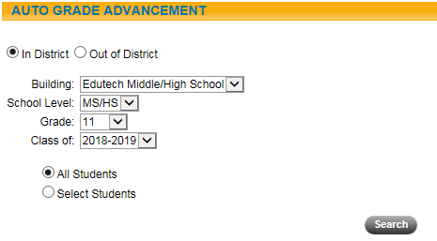

On the next screen:
- Select the Building and Grade Level
- Edit the Current Enrollment End and Start Dates
- Select the appropriate Homeroom and Counselor choices
- The students you’re advancing are displayed below. Uncheck any that you don’t want to advance to the next grade.
- Click the save icon
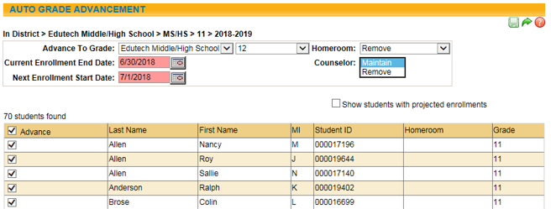
- Repeat this process, for each grade level until all grade levels have been advanced.

When you’re done:
- Counseling > Reports: Review the Auto Grade Advancement report.
- Maintenance > Counseling > Building School Level Options: Set Schedule Offset to 0.
- Maintenance > School Year > 2018-2019: Uncheck Active.
- Maintenance > School Year > 2019-2020: Check Active year and set BEDS day to 10/2/2019 (Always the first Wednesday in October).
- Counseling > Batch Enrollment Edit or Census > Student: Assign Counselor to students.
- Scheduling > Teaming Maintenance: Assign teams if they’re used.
- Counseling > Batch Enrollment Edit: Assign homerooms if they’re used.

- ENDING ENROLLMENT RECORDS: Completed by 8/16
Note: If you’re completing these tasks after 7/1, add Official enrollments instead of Projected enrollments. Whenever you select a provider from the second drop down (see example below), remember to check the “Is Placed” checkbox.

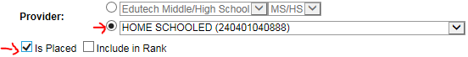

Retained Students
    - Add a projected enrollment for 7/1/XX in same grade
    - Change the “Class” on the Student > Enrollment view to the year the student is expected to graduate
    - Exit reason for current enrollment = Retained in Grade

UPK Students
If students are in a District Operated UPK in your building:
- Add a projected enrollment for 7/1/XX in grade KH or KF
- Exit reason for current enrollment = Completed Grade

If students are in a UPK outside your building:
- Add a projected enrollment for 7/1/XX in grade KH or KF
- Exit Reason for current enrollment = 153 – Transferred to another school in this district/ODP

If students are CPSE and continuing classification under CPSE/CSE they need a summer enrollment in grade PS:
- Add a projected enrollment for 7/1/XX in grade level PS with the summer services provider. (Use the same provider they had as of 6/30 if they are not going to get summer services)
- Exit Reason for current enrollment = 153 - Transferred to another school in this district/ODP
- Exit Date = 8/31/XX
- Add a Projected enrollment for 9/1/XX in grade KH or KF
- Check “Is Placed” checkbox if not enrolling in your district
- Exit Reason for current enrollment = 153 – Transferred to another school in this district/ODP

PS Students
If staying in the same placement:
- Add a projected enrollment for 7/1/XX in grade PS
- Exit Reason for current enrollment = Completed grade

If changing to a new placement:
- Add a projected enrollment for 7/1/XX with the new provider
- Exit Reason for current enrollment = 153 - Transferred to another school in this district/ODP
If Declassified:
- Exit Reason 425 – Left School, No documentation of Transfer

Out of District Placements
If staying in the same placement:
- Add a projected enrollment for 7/1/XX in the new grade level with same provider.
- Check “Is Placed” checkbox
- Exit Reason for current enrollment = Completed grade

If changing to a new placement:
- Add a projected enrollment for 7/1/XX in the new grade level and new provider.
- Check “Is Placed” checkbox if not enrolling in your district.
- Exit Reason for current enrollment = 153 - Transferred to another school in this district/ODP

5654 Enrollment in AHSEP
If continuing:
- Add a projected enrollment for 7/1/XX in same grade and same provider.
  - Exit Reason for current enrollment = Retained in grade

If completed:
- End Date = 6/30/XX
- Exit Reason = 816 – Earned a High School Equivalency Diploma

0022 Foreign Exchange Students:
    - End Date = 6/30/XX
    - Exit Reason = 442 – Left the US

0055 Instructional Reporting Only:
If not returning:
- End Date = 6/30/XX
- Exit Reason = 0066

If returning but changing to a different building:
- Add a projected enrollment for 7/1/XX
- Exit Reason for current enrollment = 0066

4034 Preschool Determining Special Education Eligibility
If continuing:
- Add a projected enrollment for 7/1/XX
- Entry Reason = 4034 – Determining Special Education Eligibility
- Exit Reason for current enrollment = 140 - Special education eligibility status determined or determination process stopped for any reason

5905 CSE Responsibility Only
If student moves out of the district:
- End Date = 6/30/XX
- Exit Reason = 8305 – End CSE Responsibility Only Enrollment

If parent places with a different provider:
- Add a projected enrollment for 7/1/XX
- Entry Reason = 5905 – CSE or CPSE Responsibility Only
- Exit Reason for current enrollment = 153 - Transferred to another school in this district/ODP

If student is remaining with the same provider:
- Add a projected enrollment for 7/1/XX
- Entry Reason = 5905-Enrolled in a Private School with same provider
- Exit Reason for current enrollment = Completed Grade

Enrolled in Private School (Parent Choice – Census Only) and Home Schooled Students
If continuing:
- Add a projected enrollment for 7/1/XX
  - Exit Reason for current enrollment = Completed Grade

If completed:
- End Date = Last day of school
- Exit Reason = Completed Grade

- PREPARATION FOR NEXT SCHOOL YEAR
Maintenance > School Year > 2019-2020
- Cycle Day Override: Set cycle day for the first day of school.
- Configuration: Verify Marking Period and Progress report dates.
- Calendar: Setup, including holidays, superintendent days, regents, etc.
- Yearly Rollover: Check the box on the left to select the remaining items that you want to roll over. Click import. (Items that have already been rolled over will have a blue check in the new school year column)
Maintenance > Attendance
- Daily Attendance Setup: Set Daily Attendance taken In for each building.
- Absentee Reasons: Any changes for next school year?
- Attendance Policy: Any changes for next school year?
- Building School Level Options: Any changes for next school year?
- How Excused: Any changes for next school year?
- Student Visits: Any changes for next school year?
Maintenance > Grading
- Honor Roll Status: Any changes for next school year?
- Gradebook setup: Any changes for next school year?
- Comment Bank: Any changes for next school year?

Maintenance > Users/Groups
- Verify the Teacher Group is set up according to district policy concerning teacher access to student records.
- Verify any parent user group access.
- Also with new versions, new permissions become available check to make sure that they are enabled, as appropriate, for each user group.

Maintenance > Scheduling > Yearly Building School Level Options
- Select your building and enter the date that you want Parents and Teachers to be able to view schedules.
Maintenance > Lockers > Update Locker assignments
- We offer a webinar in August to review the process. Check our training calendar for date and time.
Faculty
- Add new and update existing faculty. Inactivate faculty who are no longer with your district.
- Instruct staff to set their School year to the new school year: Home > Preferences > School Year.

Scheduling > Master Schedule
- Master Schedule is complete and locked
- Review reports to find common issues
  - Section Load Report – check for meeting pattern anomalies, missing rooms or missing faculty.
  - Double Book Report – assist you in finding any faculty or rooms that have been booked at the same time. Verify that some of the entries on this report are actually intended, such as gyms may have multiple PE class sections booked at the same time.
  - Faculty Schedule - review to make sure union rules have been followed and also to see if faculty can be scheduled for lunch, study hall duties. Note that if a faculty member is not scheduled during a particular period that period will not show on their schedule.
  - Student Free Period Report – this will show all students who do not have any classes or study halls placed on their schedule. This helps to verify that the study hall overlay has been done. Ideally should be run prior to printing out schedules to make sure students have something placed in all periods.
  - Final Verification – once schedule has been locked, it is recommended that someone assume a teacher ID and verify that they can access class rosters, grade book, etc. (may need to adjust the semester dates in order to see class rosters, if not officially within the school year).

Other Items to Check
- Summer School grades and program records have been entered. Check to make sure that those students who successfully completed summer school classes do not have those classes in their Fall schedules.
- Check for Projected Enrollments that need to be started.

2018-2019 School Year
Grade Level | Class Of
12 | 2018-2019
11 | 2019-2020
10 | 2020-2021
9 | 2021-2022
8 | 2022-2023
7 | 2023-2024
6 | 2024-2025
5 | 2025-2026
4 | 2026-2027
3 | 2027-2028
2 | 2028-2029
1 | 2029-2030
K | 2030-2031
PK | 2031-2032

