Summer School Setup using Alternate Enrollments

**Changes to Summer School Setup**
Instead of using a Summer School building, we are opting to use a Summer School school level. Using a Summer School school Level gives you the ability to use your automated phone call system to make attendance calls for your students attending summer school.

- Maintenance > District > Building: If you have a Summer School building select it and uncheck Active.

- Maintenance > District > School Level: Add a Summer School school level if you don’t have one.

- Maintenance > District > Building > Select your building(s) > School Level Maintenance: Add the Summer School school level. Check the appropriate grade levels and select your SS provider. Check boxes for Exclude from Day Calendar, Exclude Alternate Enrollments from School Entry Exit and Exclude from Student Daily Attendance.

- Maintenance > School Year > Next School Year > Configuration: Select your Building and the Summer School school level. Add the Semester and Marking Period dates. Note: You have to add at least 1 Marking Periods even if you don’t intend to report grades.

- Maintenance > School Year > Next School Year > Cycle Day Scheme Assignment: Select the Summer School scheme. Hint: None = Monday-Friday scheme. You can also use None for a Monday-Thursday scheme and omit Fridays on the calendar.

- Faculty: Add access to the Summer School School Level for appropriate staff. If limited permissions are required, a new user group can be created. Local or AD accounts can be used.

- Scheduling > Period Maintenance > Building > Summer School school Level > Next School Year: Add periods.

- Scheduling > Course Catalog: Add Summer School Courses.
Hint: To keep summer school courses separate from the school year courses, you can create a “Summer School” department under Maintenance > Faculty and add the courses to that department.

- Scheduling > Master Schedule > Building > Summer School school level: Add Sections. Uncheck box for Export next to teacher name.

- Scheduling > Master Schedule> Building > Summer School school Level: Lock Master Schedule

- Maintenance > Attendance > Daily Attendance Setup > Select your building(s) > Summer School school Level > Next School Year: Under Alternate Enrollments, check box for Allow Building School Level Daily Attendance.

- Maintenance > Grading > GB Setup > Select your building(s) > Summer School school Level > Next School Year: Add setup. (see example below)

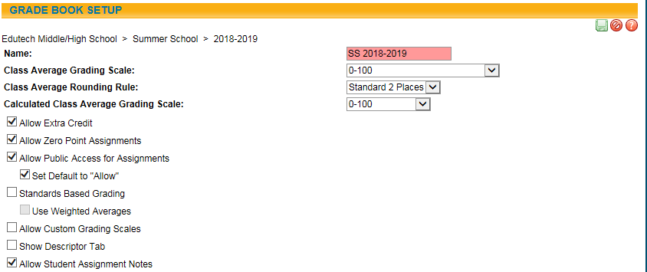

- Maintenance > Grading > BSLO > Select your building(s) > Summer School school Level: Setup General and RC options. Add Grading Details, MP Vert Avg Calc and Horiz Avg Calc.

- (optional) Maintenance > Application > Report Format > Schedule: Add format for Summer School.

- Census > Student: Add Alternate Enrollment into School Building/Summer School School Level. You can also batch add Alternate Enrollments from Counseling > Alternate Enrollments. Click the Green Plus, Choose the “Select Students” option. Using search criteria, select the students who need an alternate enrollment. Click Continue. Enter the start and end date for the alternate enrollment. Click Save

- Counseling > Counseling Search > Select next school year > click Green plus > Select the Building/Summer School. Edit period and select course section. Click Green plus. Click Save

- Students attending summer school who are also moving up to a new building in September need a projected enrollment into the new building.

In District Student? | Current Grade | Future Grade | New Building? | Projected Enrollment | Alternate SS Enrollment?
Yes | 8 | 9 | Yes | Yes | Yes
Yes | 10 | 11 | No | No | Yes
No | 10 | 11 | XX | Yes | No***
 |  |  |  | ***this is handled by the Projected Enrollment

